







**Software Requirements Specification for Rajaguru Stores**



**Rajaguru Stores Super Market POS System**

**Software Requirements Specification**

**Information Technology**

**Final Project**

**Submitted by Group No 05**

1. **13NU1220 – Samitha Rajaguru**
2. **13NU1221 – Hansana Jayathissa**
3. **13NU1222 – Dhanuka Abeywardhane**
4. **13NU1218 – Devindri Gunawardena**
5. **13NU1223 – Navin Keerthirathna**
6. **13NU1225 – Yashan Tharindu**
7. **13NU1106 – Thanula Ramasinghe**

**Submitted to:**

**…………………………………**

**(Supervisor’s signature)**

**10th October 2014**

**Table of Contents**

**Revision History 3**

1. **Introduction 4**
   1. Purpose 4
   2. Document Conventions 4
   3. Intended Audience and Reading Suggestions 4
   4. Product Scope 5
   5. References 5
2. **Overall Description 6**
   1. Product Perspective 6
   2. Product Functions 6
   3. User Classes and Characteristics 7
   4. Operating Environment 8
   5. Design and Implementation Constraints 8
   6. Project Documentation 10
   7. User Documentation 10
3. **External Interface Requirements 11**
   1. User Interfaces 11
   2. Hardware Interfaces 13
   3. Communications Interfaces 13
4. **System Features 14**
   1. Secure Login to interface 14
   2. Barcode (Unique code) Feature 15
   3. Notification Feature 16
5. **Other Non-functional Requirements 17**
   1. Performance Requirements 17
   2. Safety Requirements 18
   3. Security Requirements 18
   4. Software Quality Attributes 19
   5. Business Rules 20
6. **Other Requirements 21**

**To be Determined List 23**

**Revision History**

|  |  |  |  |
| --- | --- | --- | --- |
| **Name** | **Date** | **Reason for Change** | **Version** |
|  |  |  |  |
|  |  |  |  |
|  |  |  |  |
|  |  |  |  |
|  |  |  |  |

**1. Introduction**

**1.1. Purpose**

Rajaguru Point of Sale System is a computer based system for a store.This replace the stores’ manual System to a faster computer based system for the customer and store ease and customer and client utmost satisfaction. It will illustrate the purpose and complete declaration for the development of system. It will also explain system constraints, interface and interactions with other external applications. This document is primarily intended to be proposed to a customer for its approval and a reference for developing the first version of the system for the development team.

We will be discussing the basic functions of Grocery Rajaguru; as well any constraints associated with the overall design it. User, system, hardware and software interfaces will also be examined. Our intended audience will be possible stakeholders and investors

**1.2. Document Conventions**

The format of this SRS is simple. Bold face is used for headlines and sub headlines. Indentation is used on general topics and or specific points of interest. The remainder of the document will be written using the standard font, Calibri.

**Definitions, Acronyms and Abbreviations**

* GRN- Good Received Notes
* POS-Point of Sale

**1.3. Intended Audience and Reading Suggestions**

This document is intended to be read by the client Mr. Rajaguru. This is a technical document and the terms should be understood by the client.

This document is intended to Use by the current project team and The Rajaguru Store team, who are associated with the POS. This document contains technical information regarding the performance, specifications, and functional requirements. This document also outlines the user interfaces.

**1.4. Product Scope**

The scope of this project includes our group of developers assisted by our client, Rajaguru. The scope thus far has been the completion of the basic interfaces that will be used to build the system. The database used, has been set up and given the necessary permissions. Rajaguru POS System is designed to run on a private web server utilizing Java, Net Beans, PHP and Databases, so as to host, maintain and secure individual clients Web Stores Local information and Online and Local account information. POS System automates interaction between the client’s Local POS.

**1.5. References**

1. IEEE Software Engineering Standards Committee, “IEEE Std 830-1998, IEEE Recommended Practice for Software Requirements Specifications”, October 20, 1998.
2. Davis M A, “Just Enough Requirements Management: Where Software Development Meets Marketing”, New York, Dorset House Publishing, 2005.
3. IEEE Std 1012-1998, IEEE Standard for Software Verification and Validation
4. IEEE Std 610.12-1990, IEEE Standard Glossary of Software Engineering Terminology.2

**2. Overall Description**

**2.1. Product Perspective**

Rajaguru Stores Pvt (Ltd) is a grocery store which is using a manual system. Recently with the rising number of customers it has been facing difficulties as well as employees and stock. So the efficiency and the performance of the system are gradually decreasing.

As a solution to the above mentioned problems the client has decided to start a POS (Point Of Sale) system and an online system. The proposed system will increase the efficiency and improve the performance of the activities within the grocery shop. A well prepared database will maintain the efficiency of securing and storing the data within the system.

**2.2. Product Functions**

* Supplier Details

This is the function where the client stores the contact information of the suppliers such as supplier id, location, name and details of the supplier items.

* GRN System

The GRN system stands for Goods Received Notes. This is one of most important functions in this software. The person who orders the items will check the date of expiry and quality of the items before releasing the stuff to the stock only the items which are in good condition will be given the GRN.

* Stock Management

The stock handling system is the most important part of the software. The supplier details function, billing system and online order system directly affect the stock handling system. Ex: When a supplier supplies new items the stock will be updated and a new amount of items will be displayed.

* Notification System

There are a couple of types of notification in this system. Each notification has its own meaning and the stock holder will get the message according to the notification he receives. Ex: When a stock of items have come close to its date of expiry the stock handler will get the message that those items have come close to its expiry date.

* Billing System

Billing part is a major part of a grocery and it interacts with all daily transactions. In this system we suppose to provide chance to get a printed bill included of all necessary facts according to client’s requirements such as bought items, quantity of each, price of each and total price, Discounts. A printer connects to the machine and people who handle the system can enter all above values manually and can print the bill from a single command.

* Online Customer Registration

The customer has to register in the system first to place an order. When you register once you don’t have to register again. To access the login system first you have to enter in to the registration system.

* Online Order system

We are supposed to create an online system which customers can buy goods through an online system. For this the customer has to register in our online system and order the items and give the delivery time where customer wants the order to be delivered.

**2.3. User Classes and Characteristics**

* Administrator (Owner)

Administrator basically has all the privileges including adding new members and assigning privilege levels. The person has privilege facilities to do any sort of a modification and retrieve data.

* Online Customer

In this the customer can only change his details, other than that he can’t change anything in the system.

**2.4. Operating Environment**

* Minimum Requirements
* 2.0 Ghz processor with 2MB L2 cache memory
* 1GB DDR || RAM memory
* 50 GB HDD
* Web server
* Php, SQL, DNS server , Mail server
* To implement this grocery system does not need a very high end machine, but a good broadband internet connection is suggested to gain good performance within the system.
* Software Configuration
* Operating system (Linux, Windows, Mac Os)
* Any kind of browser
* MySQL version 5.6.20
* Xampp 1.8.3-3-VC11-server

**2.5. Design and Implementation Constraints**

We had only ten weeks for this project so we didn’t create auto generate bar code system. There is a tag that the workers paste on every product. This is what typed as the bar code in the bill. There also no credit card system.

Our database is created from my SQL so there is a limited capacity for the database.

We used Java 1.7 version and php 5.0 as programming languages and used net beans 8.0 windows as our frame work so it is too difficult to make attractive interfaces within this time period.

This system is created to do the transactions of the user by using his personal computer so according to our time schedule were unable to make that system compatible for the other devices like mobile touch pad I phone etc.

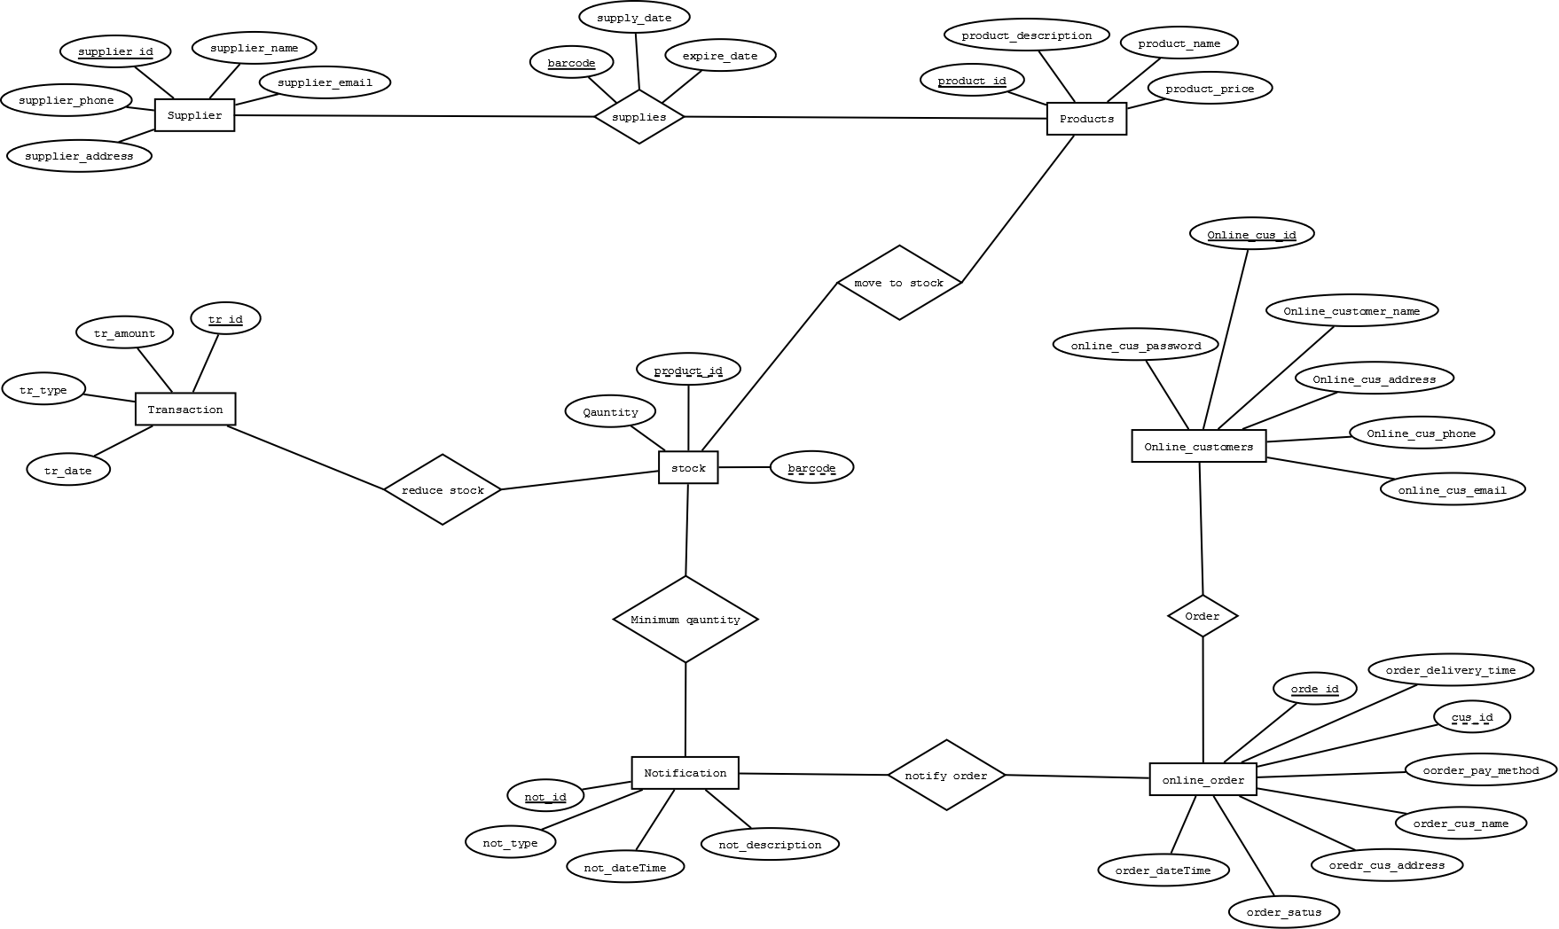

ER Diagram

**2.6. Project Documentation**

|  |  |  |
| --- | --- | --- |
| Document | Description | Activity |
| Software Project Proposal | The description of the software  Approach and associated milestones. | System requirement analysis software requirement analysis |
| Software Requirement Specification (SRS) | The description of the expected software features, constraints, interfaces and other attributes. | Process implementation |
| Software Design Description | The description of how the software will meet the client’s requirements. | System architectural design  Software architectural design |
| Software Test Documentation | The description of the plan and  Specifications to very and validate the software and the results | Software qualification testing  System qualification testing |

**2.7. User Documentation**

The User (client) will be given a brief explanation about the software and system before using it.

**3. External Interface Requirements**

**3.1 User Interface**

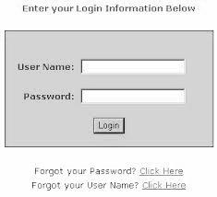

Figure 3.1.1

The first interface is the log-in screen. This is where the user (administrator/owner) has a specific Username and Password so that they can gain access to the Physical System. This is the first most interfaces you log when you give a valid user name and password. If you have forgotten your password there is a recovery method. Without accessing this interface you can’t log in to the system.

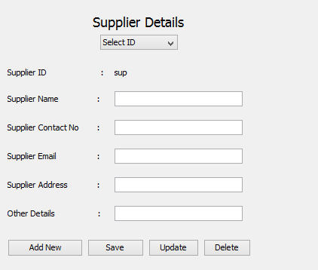

Figure 3.1.2

This is where the user enters the details about the suppliers to the system. The Combo box named as “Select ID” can retrieve information about a supplier from the database when an ID is selected. Then the information about the selected supplier could be either updated or deleted. Information about a new supplier could be added by the “Add New” button. Then the user can enter new information to the text fields and save the entered information by the “Save” button.

According to the given information above a new online customer can create a new account or a current online customer can login using the interface given below.

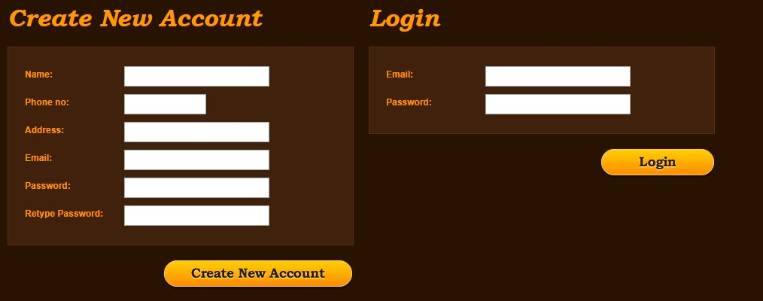

Figure 3.1.3

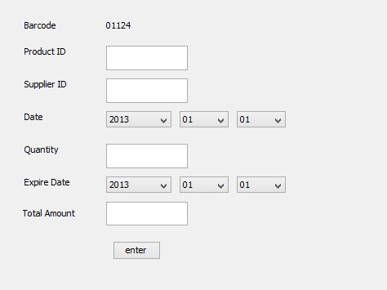

Figure 3.1.4

This is the GRN interface. This interface makes a relationship between the Supplier, products and the store/client. It contains a form of details given above, for each action a bar code will generate. This is the barcode that printed on product which include all above details. When a purchasing, the user enter manually the barcode and quantity, then it will retrieve the product’s all details and GRN details such as price, expire date.

**3.2 Hardware Interfaces**

Though not necessarily interfacing with the hardware other than the pc, the system must make use with an internet connection.

This service requires a PC able to run windows 7 or higher. 50GB of free space is recommended. Server side service requires the ability to grow dynamically based upon number of clients and frequency of communications but does not initially require a large amount of space or resources to run.

A functional mouse and keyboard are required for fully functionality of both the client and server sides.

**3.3 Communications Interfaces**

The Database is in a web server. So a good broad band connection is needed for system. It also helps in updating of the local system.

**4. System Features**

**4.1 Secure Login to interface**

This feature will give the user a secure and simple login screen. This means rather than creating try catches for a handful of error types, it just has only a handful of available and possible inputs, to prevent any improper logging in, which might cause unexpected errors, and therefore limiting the system’s capabilities.

Figure 4.1.1

It will consist of two basic fields, Username and Password. There are two buttons: Login and Lost or Forgot Password. Login will submit the entered data for approval followed by access, and the forgot password will direct the user to access his/her password which has been forgotten.

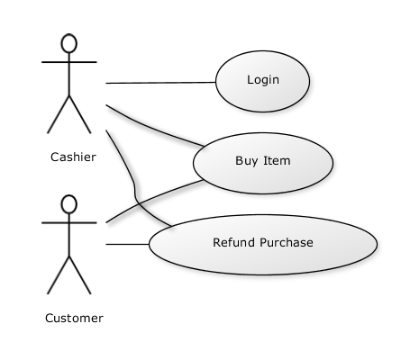

Figure 4.1.2

**4.2 Barcode (Unique code) Feature**

When supplying products the System generate different barcodes according to the varying of the expiry date, supplier date, product ID. Then this barcode is printed on the product.

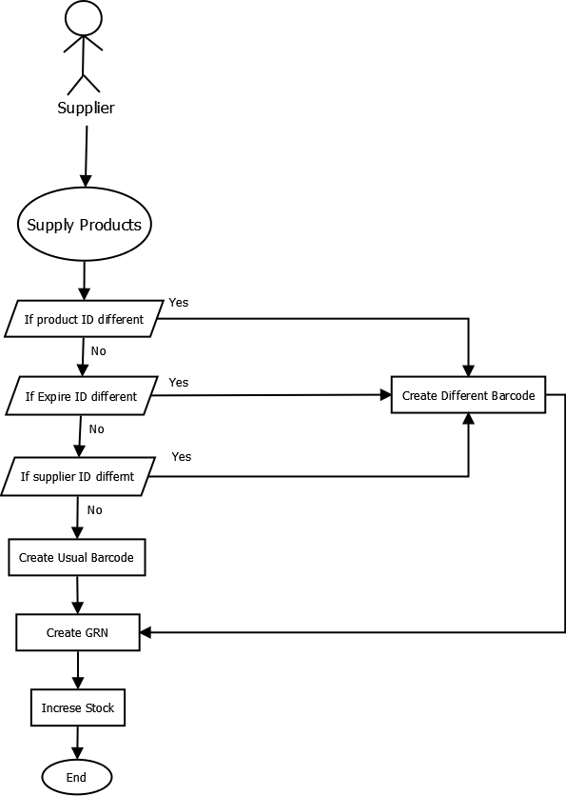

Figure 4.2.1

**4.3 Notification Feature**

Figure 4.3.1

Automatic notification is the notification where there is an indicator to indicate the minimum level of items in the stock. It also indicates when an item reaches its expiry date, week before expiring. When a customer place an order, a notification method is been built to notify the administrator about the order.

Also this automatic notification system shows the daily profit, Transactions between the customers and the client, also between the client and the suppliers.

**5. Other Non-functional Requirements**

**5.1 Performance Requirements**

This project which we are making for Rajaguru stores is platform independent. Also it can run in many kinds of devices. As an example it will work on PCs, tabs etc. so this must be also works with touch system too. According to these requirements we had to choose java as the programming language and we are currently using java 1.7 versions which have many updates and facilities to our system.

The system has to make many activities not only as a billing system as well as notification system, online ordering system and database updating system. For the online system developers have to use most recent php version, MySQL version 5.6.20, and xaamp and to make the system professional it will build by netbeans-8.0-windows version.



Those are the usual software and technical requirements for the developers. In this system we have mentioned 7 major functions. For five of them including Supplier details system, GRN system, Billing system, Notification system and Stock management system the main requirements are JAVA1.7 version as programming language, Net beans as the framework software and MySQL as the database handling software.

For other tow online systems including Online ordering system and Online Registration system developers use PHP and MySQL.

Client must have



As minimum requirements to make this system well performed. As a real time system the timing relationships are very important. If customer has above requirements he can have a well performed system which takes close to 10 seconds to load the whole program and get 1-5 seconds to move each graphical user interfaces. Also by every 30 seconds whole system is refreshing and keeps updating the system.

**5.2 Performance Requirements**

Customer has to save every detail to prevent the loss of data. This is a common mistake and system always have a command of “save”. So user has to save every detail that he or she inserts to the system. Also when deleting details user have to think twice.

If user have his own server he or she have to make a server backup to face the instant sever down. Also have to keep the hardware devices in safe place.

**5.3 Security requirements**

Access to the database should be restricted to people that are required to view information about System and day today transaction. Passwords and User Name should be regulated to be at least a certain length and must contain non-alphanumeric characters in both the password and User Name.



Figure 5.3.1

**5.4 Software Quality Attributes**

This system has lots of qualities which help to make users’ work easy. First thing is that user mustn’t be an IT person. That means user doesn’t have to be an expert in IT field. The System has very attractive interfaces and simple command words and client have to do just click the command what he wants.

Figure 5.4.1

Above picture is a simple example for how the interface looks and how it is work. User has to get details of his customers/supplier and insert into this form and save it. That is the way to insert the data and if he wants to update he can select update button. So this System is very simple to learn and use.

The System must not want higher performed machine to run. These are the common hardware that user must have.

* **2.0 GHz processor with 2MB L2 cache Memory 2GB DDR III RAM Memory**,**50 GB HDD**

Also this system had made for work with touch system and can run on any Operating System that we are currently using.so this system is flexible to run in many devices and user friendly.

User and authorized people can enter the system through a password and username. So it supplies safety to the details in system.

The online part is very important. Users’ customers can order goods through internet. And system instantly shows the user a notification that he has got a Oder. System refreshes by itself for every 30 seconds. The notification system will send notifications regarding to transactions and it also work as a remainder. As an example if user has to receive money on tomorrow system will remind the date by sending a notification. Not only that system always supplies updates about the stock and controlling stock by giving notification to user .These attributes save users’ time and keep him updating.

According to all above points user will have a safe and comfortable transactions in his day today life.

**5.5 Business Rules**

There are some important business rules which are affect to the system and requirements. If user issue a wrong bill with incorrect prices user have to print another bill.so he has to delete the previous transaction. It is a business rule and and it affects to the data base.

Also if there are expired items user needs to inform the supplier about that. Then supplier have to resupply the items.so user want communicating requirements such as e-mails, mobiles etc. Those are the business rules which affects to the non-functional requirements.

**6. Other Requirements**

1. Goods Carrying Cost
2. Damage Goods
3. Database requirements
4. Banking & Insurance

* Loan & Beholden
* Earnest Money

**1. Goods Carrying Cost**

Carrying cost of inventory is often described as a percentage of the inventory value. This percentage could include taxes, employee costs, depreciation, insurance, cost to keep items in storage, opportunity cost, cost of insuring and replacing items, and cost of capital that help produce income for a business.

**2. Damage Goods**

A person regarded as inadequate or impaired in some way. Products that are broken, cracked, scratched, etc. a person who is considered to be no longer desirable or valuable because of something that has happened: a person whose reputation is damaged.

**3. Database requirements**

This guide explains what a requirements document is, why it's a good idea to write one, how to write one, and how to use one. A requirements document explains why a product is needed, puts the product in context, and describes what the finished product will be like. A large part of the requirements document is the formal list of requirements. A lot of work happens before a requirements document is written. Your project will benefit from the time you spend finding out what the requirements are before writing them down. Once you have gathered and recorded requirements, they should be classified and prioritized. With the list of prioritized requirements and any other project documents you already have, you will be able to compile the requirements document.

**4. Banking & Insurance**

An establishment authorized by a government to accept deposits, pay interest, clear checks make loans, act as an intermediary in financial transactions, and provides other financial services to its customers. The person, group, or property for which an insurance policy is issued. The condition of having insurance.

**• Loan & Beholden**

Written or oral agreement for a temporary transfer of a property (usually cash) from its owner (the lender) to a borrower who promises to return it according to the terms of the agreement, usually with interest for its use. If the loan is repayable on the demand of the lender, it is called a demand loan. If repayable in equal monthly payments, it is an instalment loan. If repayable in lump sum on the loan's maturity (expiration) date, it is a time loan. Banks further classify their loans into other categories such as consumer, commercial, and industrial loans, construction and mortgage loans, and secured and unsecured loans. A written promise to repay the loan is called a promissory note.

**• Earnest Money**

A deposit made to a seller showing the buyer's good faith in a transaction. Often used in real estate transactions, earnest money allows the buyer additional time when seeking financing. Earnest money is typically held jointly by the seller and buyer in a trust or escrow account.

**To be Determined List**